Final Project for Computer Graphics 2026
You should make an animation based on C++ and OpenGL in this semester based on the specified base code.
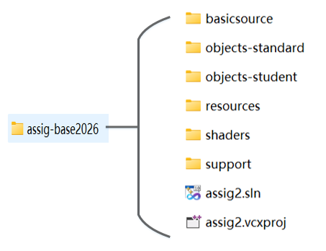
1.About the Composite Objects Requirement (50%)
You must create Two separate class-based composite objects(*.h, *.cpp) , that each have at least 8 attached child objects with geometry(primitives such as: cube, pyramid, sphere, torus, extrusion and sweep, but not limited to), and that each have at least one animation methods that animate some property of child objects, such as position, orientation, or scale.
- The child objects may be directly attached to the parent, or they may be attached indirectly via other child objects.
- Two extrusion and sweeps should be used in two composite objects.
- Each class must override the hide & show methods so that hide and show calls sent to the composite object are passed to all child objects.
- You may create additional objects to use as component parts of your composite objects.
- You must use at least two textured objects in your animation.
- You must use at least one transparent object in your animation.
- Child objects must not be hidden inside an object such that they are not visible.
- Your composite objects must be real, recognisable things (such as people, robots, cars, machines, buildings, etc.). They must not be arbitrary collections of shapes.
- The two composite objects must look significantly different to each other and must be independent of each other.
- Each composite object must have at least 2 independently animatable children. The symmetrical animatable children is one action , for example left hand and right hand. They should not be in the same actions, for example, four wheels in a car.
- The animation capability of the child components must be exposed through animation methods in each composite object. You must only animate the child parts by calling animation methods in the class, not by direct manipulation from animate Scene.
- Your composite objects must be your own creation. 0 marks for your objects that copy from your classmate or from former students in the past years.
To assist the marker, the composite object classes that will be assessed must be named composite1, composite2 . This allows the marker to distinguish the composite objects you want marked from any other composite objects that you develop as part of your animation.
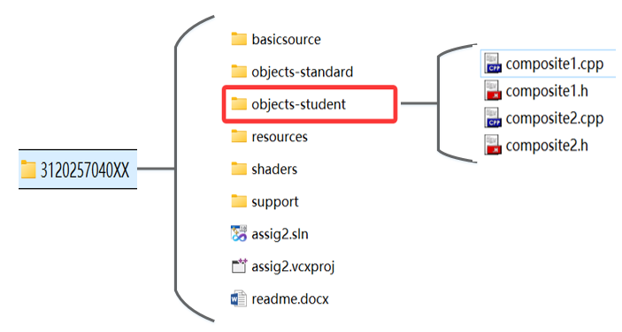
2．Other Details and Requirements
- Creativity (20%)
Interesting story with good animation characters ,background music , dubbing or camera animation.
- Demonstration :Demonstrate your program and answer questions. (15%)
Due Date & Time
Late assignment will not be accepted. Q&A and Demonstration Time is :

Final Project  (Demonstration) | 16th June | Tuesday 9:55-12:30 | GuangB 206 | GuangZhi Building
 | 21th June | Sunday 8:00-12:00 | Ji C 318 | Computer Building
Sumbission | 23th June | Tuesday 12:00(Deadline) | Exam | SuperStar System
- Documentation(15%)
You must provide either a PDF-format document named readme.pdf or a Microsoft Word document named readme.doc that describes
the hierarchy of each of your composite objects - a diagram (perhaps in exploded and/or wireframe view) is useful to augment your description
details of which of the children of each composite object have been animated, and the
names of the methods that implement the animation
 Code Quality :You are expected to use good coding style.
Files should be organized as below, no extra files should be included.
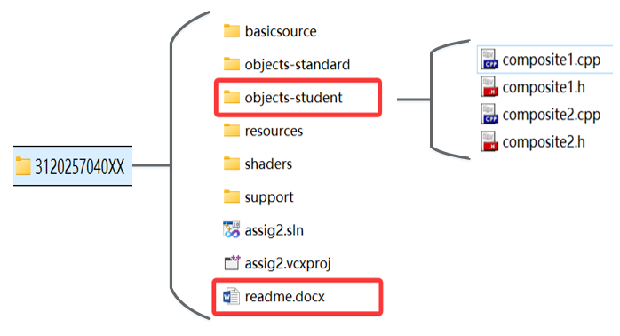
3. Things You Must NOT Do
In implementing the requirements of the assignment, note that there are some things that you
must not do. Specifically:
you must not modify the supplied sweep class or extrusion class in any way;
you must not use any 3D modelling applications to create any object for this assignment;
you must not include any 3rd-party software (such as the Quake SDK), or portions thereof
in your assignment
you must not have any sweeps, extrusions, or other objects that are "inside-out".
You must not copy code from the students in previous years.

